
Khandesh College Education Society ‘s

MOOLJI JAITHA COLLEGE, JALGAON
“An Autonomous College
Affiliated to K.B.C. North Maharashtra University, Jalgaon.”

DEPARTMENT OF STATISTICS
PROJECT REPORT ON
2022-23








GENDER INEQUALITY IN POLITICAL
SECTOR
Department of Statistics Submitted By-
Guided By Kanade Bhumika Rajendra
Dr.K.G.Khadse Bhosle Devyani Sunil
Tele Kalpesh Dhanraj
Badgujar Krushna Padmakar
Patil Premnath Pradip

CERTIFICATE
This is to certify that Kanade Bhumika Rajendra, Bhosle Devyani Sunil, Tele Kalpesh Dhanraj, Badgujar Krushna Padmakar, Patil Premnath Pradip are the students of T.Y. BSc. STATISTICS at M.J.College, Jalgaon have successfully completed their project entitled “GENDER INEQUALITY IN POLITICAL SECTOR” under my guidance and supervision during the academic year 2022-23.









Place: Jalgaon Date:

Prof.Dr.K.G.Khadse
(Head of Dept.Statistics) (Head of Dept. Statistics)
(Project Guided) ACKNOWLEDGEMENT









We would like to express our special gratitude and thanks to our mentor and project guide Prof.Dr.K.G.Khadse sir for his time and efforts he provided throughout the semester. Your useful advice and suggestions were really helpful to us during the project’s completion. In this aspect, we are eternally grateful to you. We would also like to thank our statistics teachers Prof. Suraj Vishwakarma sir and Miss.Ashwini Patil mam for their valuable guidance suggestions and time given to us. We also like to extend our gratitude to the Statistics department and teachers for providing us with all the facilities that were required.

- Kanade Bhumika Rajendra
- Bhosle Devyani Sunil
- Tele Kalpesh Dhanraj
- Badgujar Krushna Padmakar • Patil Premnath Pradip

INDEX

Sr. No | Contents | Page No
1 | INTRODUCTION | 6
2 | OBJECTIVES | 7
3 | INFORMATION    1.Lok Sabha elections    2. State Assembly Elections (Vidhan-Sabha) | 8  9
4 | METHODOLOGY    1.Collection of Data    2. Limitations Of Data Collection  3. Collected Data  4  .Variable Creation | 12  12  12  13
5 |   ANALYTICAL METHODS  1.Correlation  2.Time Series Analysis By Least Square Method  3.Chi square test for independence of attributes | 14  15  16
6 | RESULTS | 18
7 | LIMITATIONS | 35
8 | REFERENCES | 36

INTRODUCTION

Gender inequality in politics is a persistent issue in India, where women are vastly underrepresented in positions of political power. While women constitute approximately half of the country's half of the population, they hold less than 23% of the seats in the Indian parliament, which is significantly lower than the global average of 25%.








Some key factors that contribute to gender inequality in politics in India include patriarchal attitudes and cultural norms that prioritize male leadership and discourage women from pursuing political careers. Additionally, there are often significant barriers to women's participation in politics, including limited access to education and resources, as well as harassment and discrimination.
Despite these challenges, there have been some notable efforts to promote gender equality in politics in India, including the reservation of seats for women in local government bodies through the Constitution (74th Amendment) Act, 1992. However, there is still a long way to go to achieve true gender parity in Indian politics.

OBJECTIVES
The objective of this project appears to be to explore genderbased political inequality in India and to examine the relationship between the number of women contestants and the number of women elected to political office. Specifically, the project aims to analyze data from the Lok Sabha elections in India to understand the extent of women's political representation in India and to identify factors that may contribute to or hinder women's political participation and leadership.
Through this project, we may aim to:








Explore the factors that contribute to gender-based political inequality in India, including patriarchal attitudes and practices, political party dynamics, and cultural norms and expectations.
To analyse data from the Lok Sabha and State Assembly elections to identify patterns and trends in women's political participation and representation.
Examine the relationship between the number of women contestants and the number of women elected to political office, and explore potential factors that may influence this relationship.
Identify strategies and interventions that can promote women's political participation and leadership in India.
Overall, the objective of this project is to contribute to a better understanding of gender-based political inequality in India and to identify ways to promote more equitable and inclusive political representation.

INFORMATION
Lok Sabha elections:
The Lok Sabha, constitutionally the House of the People, is the lower house of India's bicameral Parliament, with the upper house being the Rajya Sabha. Members of the Lok Sabha are elected by an adult universal suffrage and a first-past-the-post system to represent their respective constituencies, and they hold their seats for five years or until the body is dissolved by the President on the advice of the council of ministers. The house meets in the Lok Sabha Chambers of the Sansad Bhavan, New Delhi.








The maximum membership of the House allotted by the Constitution of India is 552 (Initially, in 1950, it was 500). Currently, the house has 543 seats which are made up by the election of up to 543 elected members and at a maximum. Between 1952 and 2020, 2 additional members of the Anglo-Indian community were also nominated by the President of India on the advice of Government of India, which was abolished in January 2020 by the 104th Constitutional Amendment Act, 2019.
The Lok Sabha elections are critical for the governance of the country, as the members of the Lok Sabha are responsible for passing laws and policies that impact the lives of all citizens. The results of the elections can also impact the national political scenario, as the party or coalition with a majority in the Lok Sabha forms the government at the centre.

The Lok Sabha elections are of great importance to the Indian democracy as they give citizens a chance to choose their representatives who will govern the country for the next five years. The elections also serve as a barometer of public opinion on various issues affecting the nation.

State Assembly Elections (Vidhana-Sabha):








The State Legislative Assembly, or Vidhan Sabha, is a legislative body in the states and union territories of India. In the 29 states and 3 union territories with a unicameral state legislature, it is the sole legislative body and in 6 states it is the lower house of their bicameral state legislatures with the upper house being State Legislative Council. 5 union territories are governed directly by the Union Government of India and have no legislative body.
State assembly elections in India are held to elect the members of the legislative assembly in each state of the country. The legislative assembly is the primary law-making body of the state, and its members are elected through a direct vote by eligible citizens.
The frequency of state assembly elections varies by state and is typically held every five years. However, in some cases, the elections may be held earlier if the government is dissolved before the end of its term.
The process of state assembly elections is similar to that of national elections in India. The Election Commission of India is responsible for conducting the elections and ensures that the electoral process is free and fair. Before the elections, the commission

announces the dates of the elections and issues guidelines for candidates and political parties.








State assembly elections are crucial for the governance of each state as the members of the legislative assembly are responsible for enacting laws and policies that impact the lives of citizens. The results of state assembly elections can also impact the national political scenario, as some states have a significant number of seats in the national parliament.
Overall, state assembly elections are an essential aspect of the democratic process in India, allowing citizens to choose their representatives and participate in the governance of their state.
Each Member of the Legislative Assembly (MLA) is directly elected to serve 5-year terms by single-member constituencies. The Constitution of India states that a State Legislative Assembly must have no less than 60 and no more than 500 members however an exception may be granted via an Act of Parliament as is the case in the states of Goa, Sikkim, Mizoram and the union territory of Puducherry which have fewer than 60 members. A State Legislative Assembly may be dissolved in a state of emergency, by the Governor on request of the Chief Minister, or if a motion of no confidence is passed against the ruling majority party or coalition.

Why there is a need of gender equality in political elections?
Gender equality is essential in political elections in India for various reasons. Firstly, women constitute nearly half of India's population, and therefore, their participation in the political process is crucial for representative democracy. The presence of women in elected bodies ensures that the concerns and issues that are specific to them are adequately represented and addressed.








Secondly, gender equality in political elections is necessary to overcome the historical disadvantage faced by women in Indian society. Women in India have traditionally been excluded from the public sphere and denied access to education and opportunities. This has resulted in their under-representation in politics, with women holding only a small fraction of elected positions.
Thirdly, gender diversity in elected bodies has been shown to result in better governance outcomes. Studies have demonstrated that women's representation in politics is linked to improved health and education outcomes, reduced corruption, and better allocation of public resources.
In conclusion, gender equality in political elections is critical for building a more inclusive and representative democracy in India. It is essential to ensure that all sections of society have an equal say in the political process and that the concerns of women are adequately addressed.
| P a g e

METHODOLOGY
1)Collection of Data:
We want to study “GENDER INEQUALITY IN POLITICAL SECTOR”. So have to use Secondary sources such as government reports, academic articles, and news articles can be used to gather data on the number of women contestants and the number women elected to political sector in past elections.








We have taken secondary data from the www.eci.gov.in. Election Commission of India Official website help us to get election figure of Lok-Sabha and India’s all State Assembly. We collected data of year wise election from 1957 to onward elections and we can study the Women elected, Women Contestants, percentage of women in Assembly, Success Rate of Women as compared to Men.

2)Limitation of Data Collection:
We could only focus on Lok-Sabha and State Assembly. We couldn’t include the Rajya-Sabha and local political legislative councils &Municipal Corporation, Gram panchayat, etc. in our data collection.
As assembly elections are not held in the Union Territories of India, we could not collect the relevant data .

3)Collected Data:
Here is a dataset of our collected election figures of Lok-
Sabha from year 1957 to latest previous election year 2019

 | Sr. No. | Election Year | No. of men contestants | No. of women contestants | No. of Seats | No. of Men MPs | No. of women MPs
 | 1 | 1957 | 1474 | 45 | 494 | 472 | 22
 | 2 | 1962 | 1919 | 66 | 494 | 463 | 31
 | 3 | 1967 | 2302 | 67 | 523 | 494 | 29
 | 4 | 1971 | 2701 | 86 | 521 | 493 | 28
 | 5 | 1977 | 2369 | 70 | 544 | 525 | 19
 | 6 | 1980 | 4486 | 143 | 544 | 516 | 28
 | 7 | 1984 | 5321 | 171 | 544 | 501 | 43
 | 8 | 1989 | 5962 | 198 | 529 | 500 | 29
 | 9 | 1991 | 8419 | 330 | 509 | 470 | 39
 | 10 | 1996 | 13353 | 599 | 541 | 501 | 40
 | 11 | 1998 | 4476 | 274 | 545 | 502 | 43
 | 12 | 1999 | 4364 |   284 | 543 | 494 | 49
 | 13 | 2004 | 5080 |   355 | 543 | 498 | 45
 | 14 | 2009 | 7514 | 556 | 543 | 484 | 59
 | 15 | 2014 | 7583 |   668 | 543 | 477 | 66
 | 16 | 2019 | 7316 | 724 | 542 | 464 | 78


We also have the similar data set for all 29 State Assemblies.



4)Variable Creation:

Women political participation are study by some factor are to be under consideration such as Total Seats in Assembly, Number of Women Elected, Number of Men Elected, Total Numbers of Contestants, Number of Women Contestants, Number of Men Contestants, Percentage of Women in Assembly, Percentage of Men in Assembly, Winning percentage of Women, Winning percentage of Men. So far the Descriptive Analysis we take all above the variables are founded the election figures of respective Assembly. So far time series analysis we take Number of Women Elected as dependent variable which depends on independent variable as Election Year

12 | P a g e

ANALYTICAL METHODS
1.Correlation:
Correlation is a statistical measure that describes the degree of association or relationship between two variables. In other words, correlation measures how closely related two variables are to each other.
The most commonly used measure of correlation is Pearson's correlation coefficient, which is denoted by the symbol "r". Pearson's correlation coefficient is a measure of the linear relationship between two variables, and it ranges from -1 to 1.








If r is positive, it indicates a positive correlation, meaning that as one variable increases, the other variable also tends to increase. If r is negative, it indicates a negative correlation, meaning that as one variable increases, the other variable tends to decrease. If r is close to zero, it indicates little or no correlation, meaning that there is no relationship between the two variables.
The strength of the correlation can also be determined by the absolute value of r. A correlation coefficient of 1 or -1 indicates a perfect correlation, while a coefficient of 0 indicates no correlation.
It is important to note that correlation does not imply causation. Just because two variables are correlated does not necessarily mean that one variable causes the other variable to change. Correlation simply indicates that there is a relationship between the two variables.

2.Time series analysis by Least square Method:
Time series analysis by least square method is a technique used to estimate the trend in a time series by fitting a linear regression model to the data. The least square method is a popular technique used to estimate the parameters of a linear regression model.
In time series analysis, the data is a sequence of observations that are taken over time. The goal of time series analysis is to identify patterns and trends in the data, and to make predictions about future values based on these patterns.
The least square method involves fitting a straight line to the data using the formula:
y = a + bx
where y is the dependent variable (i.e., the time series data), x is the independent variable (i.e., the time), a is the intercept, and b is the slope of the line.








To use the least square method for time series analysis, the first step is to plot the data and examine it for any patterns or trends. If the data shows a linear trend, then the least square method can be used to estimate the trend.
The next step is to calculate the slope and intercept of the line using the least square method. The slope (b) is calculated using the formula:
b = Σ((x-x̅) *(y-ȳ)) / Σ(x-x̅)^2

where x̅ is the mean of the independent variable, ȳ is the mean of the dependent variable, and Σ represents the sum of the values.
The intercept (a) is then calculated using the formula:
a = ȳ - bx̅
Once the slope and intercept have been calculated, the fitted line can be plotted on the graph along with the original data. This line represents the estimated trend in the time series.








It is important to note that the least square method assumes that the residuals (the differences between the observed values and the values predicted by the regression line) are normally distributed and have constant variance. If these assumptions are not met, other methods such as time series decomposition or exponential smoothing may be more appropriate for analysing the data.

3.Chi-square test for independence of attributes:
The chi-square test for independence of attributes is a statistical test used to determine whether two categorical variables are independent of each other or not. This test is used when we have two categorical variables and we want to know whether there is a relationship between them.
The null hypothesis of the chi-square test for independence is that there is no association between the two variables. The alternative hypothesis is that there is an association between the two variables.








To perform the chi-square test for independence, we first need to construct a contingency table. A contingency table is a table that shows the frequency distribution of one variable for each category of the other variable. Once we have the contingency table, we can calculate the expected frequencies for each cell under the assumption of independence.
The test statistic is then calculated as the sum of the squared differences between the observed and expected frequencies, divided by the expected frequencies. The degrees of freedom for the test are calculated as (r-1)*(c-1), where r is the number of rows and c is the number of columns in the contingency table.
If the calculated test statistic is greater than the critical value from the chi-square distribution with the appropriate degrees of freedom and alpha level, we reject the null hypothesis and conclude that there is a significant association between the two variables. If the calculated test statistic is less than the critical value, we fail to reject the null hypothesis and conclude that there is no significant association between the two variables.
The chi-square test for independence is widely used in social science, marketing research, and quality control, among other fields. It is a useful tool for exploring the relationships between two categorical variables and determining whether they are related or not.

























RESULTS

:
.Descriptive Statistics
1

Overview of Lok
-
Sabha:

-

67
86
70
143
171
198
330
274
284
355
556
668
724
0
100
200
300
400
500
600
700
800
1967

1971

1977

1980

1984

1989

1991

1998

1999

2004

2009

2014

2019

No. of women contenstants
22
31
29
28
19
28
43
29
39
43
49
45
59
66
78
0
10
20
30
40
50
60
70
80
90
1957

1962

1967

1971

1977

1980

1984

1989

1991

1998

1999

2004

2009

2014

2019

No. of Women Elected.
Year
No. of women MPs Elected.
Election Figures: -
1957- 22 female MPs (4.453%)
1962- 31 female MPs (6.275%)
1967- 29 female MPs (5.545%)
1971- 28 female MPs (5.374%)
1977- 19 female MPs (3.493%)
1980- 28 female MPs (5.147%)
1984- 43 female MPs (7.904%)
1989- 29 female MPs (5.482%)
1991- 39 female MPs (7.662%)
1996- 40 female MPs (7.394%)
- 43 female MPs (7.889%)
- 49 female MPs (9.024%)
2004- 45 female MPs (8.287%)








2009- 56 female MPs (10.865%)
2014- 66 female MPs (12.154%)
2019- 78 female MPs (14.391%)
Average % of female MPs= (7.584%)



Description:

The percentage of women MPs has never exceeded 15% of the
total seats, in the parliament.

It has been highest i.e., 14.39% in 2019
Lok
-
Sabha elections.

In 1977 Lok
-
Sabha elections there were only 3.49% female MPs
in Lok
-
Sabha.

92.4160963
7.5839037
Percentage of Men vs Women
In USA, the percentage of Latest Election of Women is around 27% in White House parliament.

State-wise average % of female MLAs in Assembly:
Election Figure:

Sr. No. | State | % of Women in assembly | % of Men in assembly
1 | Andhra Pradesh | 5.8605 | 94.1011676
2 | Arunachal Pradesh | 2.6666 | 97.3334
3 | Assam | 4.8758 | 95.1241
4 | Bihar | 6.2169 | 93.783
5 | Chhattisgarh |   10.8333 | 89.1667
6 | Delhi | 7.511 | 92.489
7 | Goa |   3.5897 | 96.4103
8 | Gujrat | 5.0529 | 94.9471
9 | Haryana |   7.5783 | 92.4217
10 | Himachal Pradesh |   4.6447 | 95.3553
11 | Jharkhand | 8.9508 | 91.0492
12 | Karnataka |   3.2802 | 96.7197
13 | Kerala | 4.4721 | 95.5279
14 | Madhya Pradesh |   6.4658 | 93.5342
15 | Maharashtra |   4.3478 | 95.6521
16 | Manipur | 1.6809 | 98.3191
17 | Meghalaya |   2.8418 | 97.1582
18 | Mizoram |   0.7638 | 99.2362
19 | Nagaland | 0 | 100
20 | Odisha | 4.979 | 95.021
21 | Punjab | 5.5749 | 94.4251
22 | Rajasthan | 6.8132 | 93.1867
23 | Sikkim | 5.5555 | 94.4444
24 | Tamilnadu | 5.4516 | 94.5484
25 | Telangana | 6.7261 | 93.2739
26 | Tripura | 3.4848 | 96.5152
27 | Uttarakhand | 7.4451 | 92.5548
28 | Uttar Pradesh | 5.5023 | 94.4977
29 | West Bengal | 6.8567 | 93.1432

Distribution of Percentage in State-wise assembly in India’s Map.

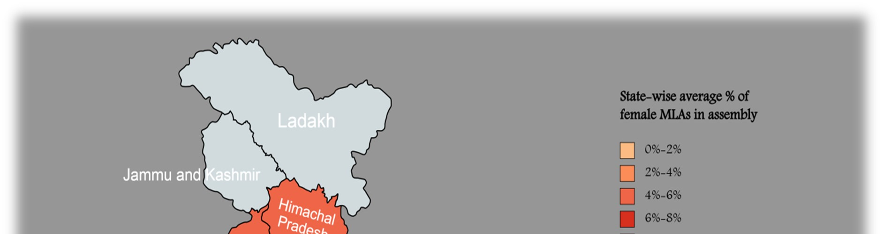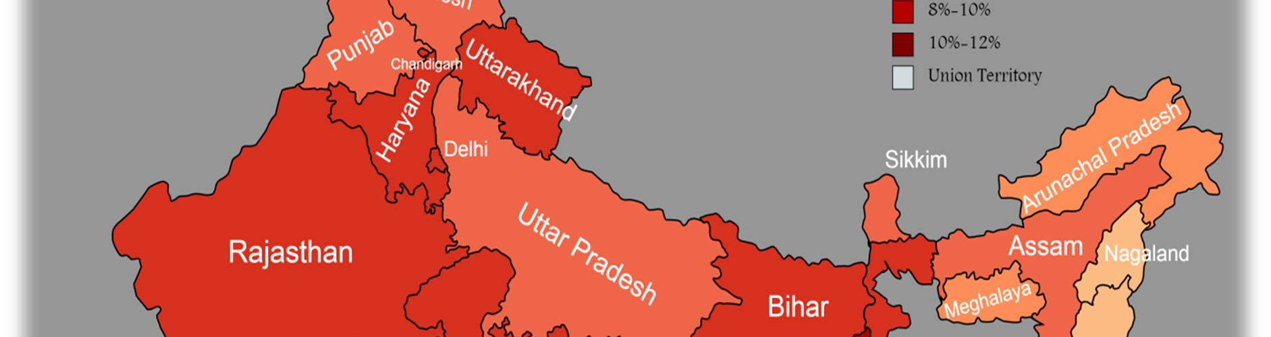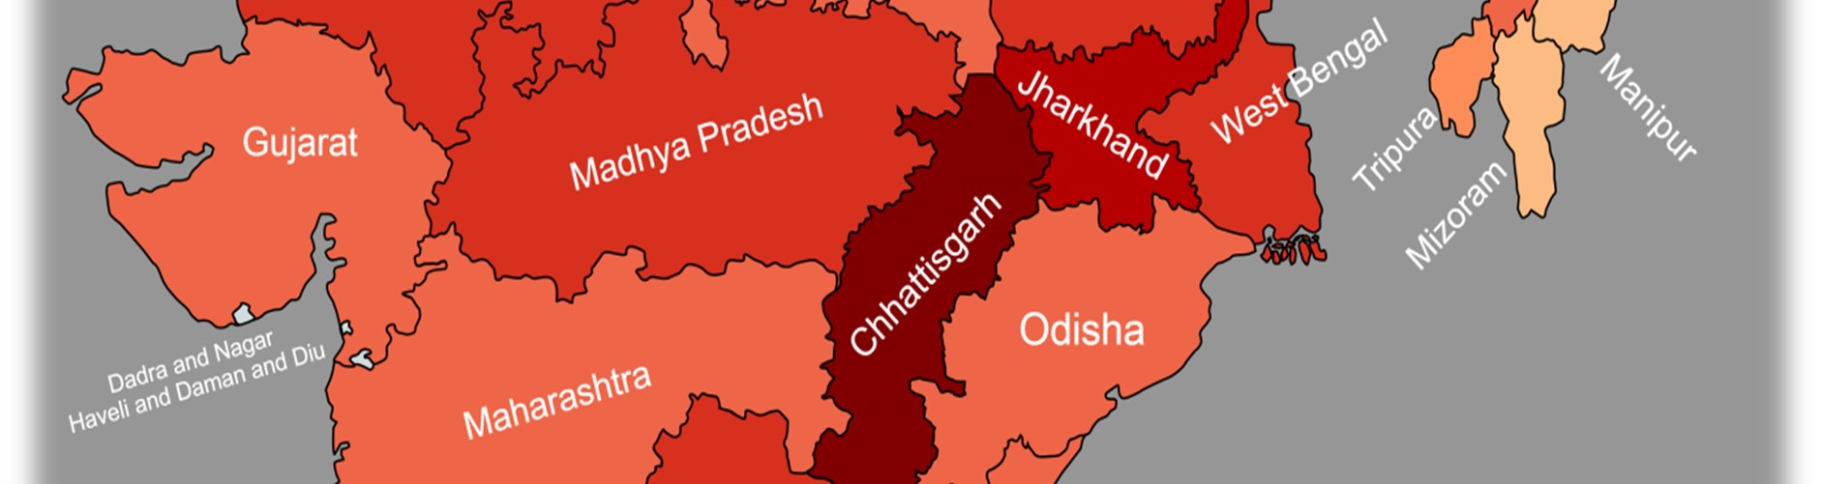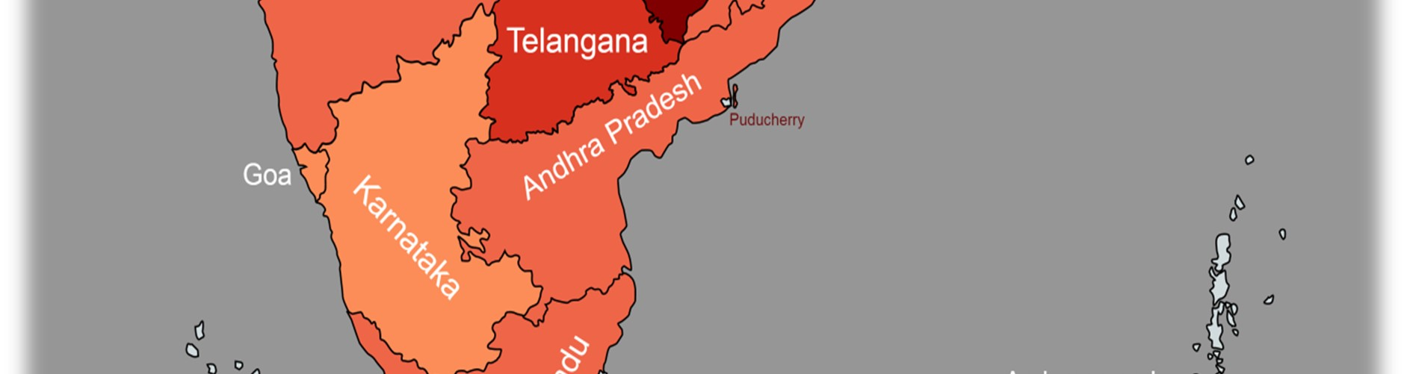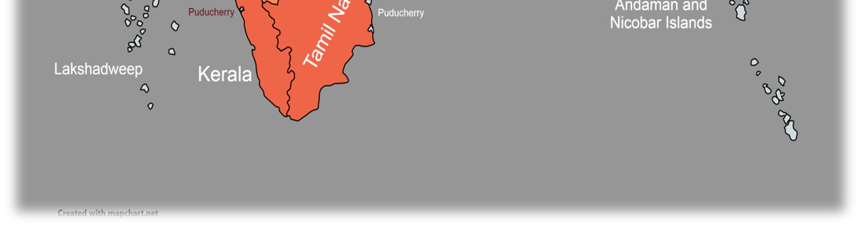











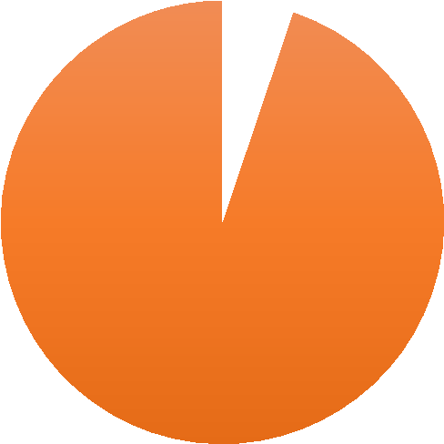

Description:
-

At the state assembly, it is even lower than in the Lok
-
S
abha.

The state Nagaland has the lowest mean percentage of women in the
state assembly which is 0 percent.

Whereas Chhattisgarh has the highest mean
percentage i.e.,
%
10.833
.

In Andhra Pradesh, Gujarat, Punjab, Tamil Nadu and Uttar
Pradesh, the female mean percentage rate is closer to the average.

About 15 states have higher than the average female mean
percentage rate, however 14 states are below the average rate.

The State where literacy rate is higher but proportion of
women in assembly is less.

).
(
for ex, Kerala, Karnataka, Maharashtra, etc

The State where literacy rate is less but proportion of women
is assembly is higher.

(
for ex, Chhattisgarh, Jharkhand, Bihar, etc.
)

5.173175862
,
%
5
94.82547474
,
%
95
Mean % of men & Women in state assembly
Female
Male











Overview of Maharashtra State Assembly
:

36
19
56
51
47
83
144
247
86
137
211
277
235
13
9
0
8
19
16
6
11
12
12
11
20
24
0
50
100
150
200
250
300
1962

1967

1972

1978

1980

1985

1990

1995

1999

2004

2009

2014

2019

















Election Figures:

1962
-

13
)
Female MLAs (4.924%

1967
-

9
Female MLAs (3.333%
)

1972
-

0
Female MLAs (0%
)

1978
-

8
Female MLAs (2.778%)

1980
-

19
)
Female MLAs (6.597%

1985
-

)
16
Female MLAs (5.556%

1990
-

Female MLAs (2.083%
6
)

1995
-

)
11
Female MLAs (3.819%

1999
-

)
Female MLAs (4.167%
12

2004
-

Female MLAs (4.167%
)
12

2009
-

Female MLAs (3.819%
)
11

2014
-

20
Female MLAs (6.944%
)

2019
-

24
Female MLAs (8.333%
)

Average % of Female MP’s in Maharashtra (4.3478%)

4.347804973
,
4
%
95.65219503
,
96
%
Percentage of Men vs Female in Maharashtra State
1
2

2.Correlation: -
Here we are interested in to find out if there is any relation between the two variables under study such as Women Elected and Women Contestants and Correlation Coefficient between Men Elected and Men Contestants.
Lok Sabha: -




In Lok Sabha we can see that of trend of Women Elected and Women Contestants are consistently in upward direction. Hence the Correlation Coefficient of Women Elected and Women Contestants is (0.886229122) and hence there is a Strong Positive Correlation between Women Elected and Women Contestants and Correlation
Coefficient of Men Elected and Men Contestants is (-0.073766981)
   |  | Female  Contestants in Lok-Sabha  Elections | Elected  Women
Female  Contestants in  Lok-Sabha  Elections |   Pearson Correlation | 1 | .886**
 |   Sig. (2  -  tailed) |  | <.001
 | N | 16 | 16
Elected Women | Pearson Correlation | .886** | 1
 | Sig. (2-tailed) | <.001
 | N | 16 | 16

**Correlation is significant at the 0.01 level (2-tailed).

 |  | Male  Contestants In  Lok-Sabha  Elections | Elected Men
Male Contestants In Lok-Sabha Elections | Pearson Correlation | 1 | -.074
 | Sig. (2-tailed) |  | .786
 | N | 16 | 16
Elected Men | Pearson Correlation | -.074 | 1
 | Sig. (2-tailed) | .786
 | N | 16 | 16










Maharashtra: -
 |  | MH Women  Contestants | MH Elected women
MH Women  Contestants | Pearson Correlation | 1 | .419
 |   Sig. (2  -  tailed) |  | .154
 |   N | 13 | 13
MH Elected women |   Pearson  Correlation | .419 | 1
 |   Sig. (2  -  tailed) | .154
 | N | 13 | 13
 |  | MH Male Contestants | MH Elected Men
MH Male Contestants |   Pearson  Correlation | 1 | .473
 | Sig. (2-tailed) |  | .103
 |   N | 13 | 13
MH Elected Men | Pearson Correlation | .473 | 1
 | Sig. (2-tailed) | .103
 | N | 13 | 13


In Maharashtra state assembly we can see that of trend of Women Elected and Women Contestants are consistently in upward direction. Hence Correlation Coefficient of Women Elected and Women Contestants is 0.4189 and Correlation Coefficient of Men Elected and Men Contestants is 0.4730.

Assam: -

 |  | Assam Men  Contestants | Assam Men  Elected
Assam Men  Contestants | Pearson Correlation | 1 | .495
 | Sig. (2-tailed) |  | .072
 | N | 14 | 14
Assam Men  Elected | Pearson Correlation | .495 | 1
 |   Sig. (2  -  tailed) | .072
 |   N | 14 | 14
 |  | Assam Women  Contestants | Assam  Elected  Women
Assam Women contestants |   Pearson Correlation | 1 | .751**
 |   Sig. (2  -  tailed) |  | .002
 | N | 14 | 14
Assam Elected  Women |   Pearson  Correlation | .751** | 1
 | Sig. (2-tailed) | .002
 | N | 14 | 14


**Correlation is significant at the 0.01 level (2-tailed) Bihar: -
 |  | Bihar Men Contestants | Bihar Men  Elected
Bihar Men Contestants | Pearson Correlation | 1 | .207
 | Sig. (2-tailed) |  | .459
 | N | 15 | 15
Bihar Men Elected | Pearson Correlation | .207 | 1
 |   Sig. (2  -  tailed) | .459
 |   N | 15 | 15
 |  | Bihar Women  Contestants | Bihar  Elected  Women
Bihar Women  Contestants |   Pearson Correlation | 1 | .533*
 | Sig. (2-tailed) |  | .041
 | N | 15 | 15
Bihar Elected  Women | Pearson Correlation | .533* | 1
 | Sig. (2-tailed) | .041
 | N | 15 | 15




**Correlation is significant at the 0.05 level (2-tailed) Meghalaya: -
 |  | Meghalaya  Men  Contestants | Meghalaya Elected Men
Meghalaya Men  Contestants | Pearson Correlation | 1 | -.561
 | Sig. (2-tailed) |  | .092
 | N | 10 | 10
Meghalaya Elected men |   Pearson  Correlation | -.561 | 1
 |   Sig. (2  -  tailed) | .092
 |   N | 10 | 10
   |  | Meghalaya Women  Contestant  s | Meghalaya Elected Women
Meghalaya Women  Contestants | Pearson  Correlation | 1 | .629
 | Sig. (2-tailed) |  | .051
 | N | 10 | 10
Meghalaya Elected  Women | Pearson Correlation | .629 | 1
 | Sig. (2-tailed) | .051
 | N | 10 | 10




Tamilnadu: -
 |  | Tamilnadu  Men  Contestants | Tamilnadu Elected Men
Tamilnadu Men  Contestants | Pearson Correlation | 1 | -.618*
 | Sig. (2-tailed) |  | .024
 | N | 13 | 13
Tamilnadu  Elected Men |   Pearson  Correlation | -.618* | 1
 | Sig. (2-tailed) | .024
 |   N | 13 | 13
 |  | Tamilnadu  Women  Contestants | Tamilnadu  Elected  Women
Tamilnadu Women  Contestants |   Pearson  Correlation | 1 | .449
 |   Sig. (2  -  tailed) |  | .124
 | N | 13 | 13
Tamilnadu Elected  Women | Pearson Correlation | .449 | 1
 | Sig. (2-tailed) | .124
 | N | 13 | 13





**Correlation is significant at the
0.05
level
(2
-
tailed
)

We Examine Correlation Coefficient between Women Elected and Women Contestants all the 29-State Assembly are between positive moderate and strong positive correlation.

Conclusion: - The analysis of the data reveals that there is a positive correlation between the number of women contestants and the number of women elected. This suggests that “increasing the number of women contestants can help to increase the representation of women” in political leadership positions.










3.Time Series analysis by Least Square method:-

Year(t) | % of female MPs (Y) | X=t-1989 | X^2 | XY | Exp. %
1957 | 4.453441296 | -32 | 1024 | -142.51 | 3.270758
1962 | 6.275303644 | -27 | 729 | -169.433 | 3.944687
1967 | 5.544933078 | -22 | 484 | -121.989 | 4.618616
1971 | 5.37428023 | -18 | 324 | -96.737 | 5.157759
1977 | 3.492647059 | -12 | 144 | -41.9118 | 5.966474
1980 | 5.147058824 | -9 | 81 | -46.3235 | 6.370832
1984 | 7.904411765 | -5 | 25 | -39.5221 | 6.909975
1989 | 5.482041588 | 0 | 0 | 0 | 7.583904
1991 | 7.662082515 |   2 | 4 | 15.32417 | 7.853475
1996 | 7.393715342 | 7 | 49 | 51.75601 | 8.527404
1998 | 7.889908257 |   9 | 81 | 71.00917 | 8.796976
1999 | 9.023941068 |   10 | 100 | 90.23941 | 8.931762
2004 | 8.287292818 | 15 | 225 | 124.3094 | 9.605691
2009 | 10.86556169 |   20 | 400 | 217.3112 | 10.27962
2014 | 12.15469613 | 25 | 625 | 303.8674 | 10.95355
2019 | 14.39114391 |   30 | 900 | 431.7343 | 11.62748
Sum | 121.3424592 |   -  7 | 5195 | 647.1249



Y=a+b*X
∑Y=n*a+b*∑X
∑X*Y=a*∑X+b*∑X^2 a=7.583904 b=0.134786

The Secular Trend line for % of Female MPs is given by the equation,
Y = 7.583904 + 0.134786 X
From above equation estimated percentage of Female MPs in Lok-Sabha are:
2024 - 12.032 %
2029 - 12.706 %
2034 - 13.380 %
2039 - 14.054 %
2044 - 14.728 %









is:

Similarly, By time series analysis, the Secular Trend line
for %
of Female MLAs is given by the equation,

Y = 4.3478 + 0.059 X

From above equation estimated percentage of Female MLAs
2024 - 6.37 %
2029 - 6.67 %
2034 - 6.96 %
2039 - 7.26 %
2044 - 7.56 %

4.Chi-square test for independence of attributes:-

Chi-Square Test for Association:

Rows: C1 Columns: Worksheet columns

 | Assam | Bihar | Meghalaya | Maharashtra | Tamilnadu | All
Male | 95 | 94 | 97 | 96 | 95 | 477
 | 95.400 | 95.400 | 95.400 | 95.400 | 95.400
 | -  0.4000 | -  1.4000 | 1.6000 |   0.6000 | -0.4000
 | -  0.0410 | -  0.1433 | 0.1638 |   0.0614 | -0.0410
Female | 5 | 6 | 3 |   4 | 5 | 23
 | 4.600 | 4.600 | 4.600 | 4.600 | 4.600
 | 0.4000 | 1.4000 | -1.6000 |   -  0.6000 | 0.4000
 | 0.1865 | 0.6528 | -0.7460 | -0.2798 | 0.1865
 |  |  |  | 
All | 100 | 100 | 100 | 100 | 100 | 500



Cell Contents

Standardized residual

Chi
-
Square Test

Count
Expected count
Residual
Chi- P-
Square DF Value
Pearson 1.185 4 0.881
Likelihood 1.228 4 0.874
Ratio
5 cell(s) with expected counts less than 5.

Conclusions
1.Factors responsible for Gender inequality in Political Sector in India.
There are several factors responsible for gender inequality in political elections in India. Some of these factors include:
Patriarchal societal norms:
India is a patriarchal society, where men have traditionally held positions of power and decision-making authority. These societal norms make it difficult for women to participate in politics and gain access to positions of power.
Limited access to education:








Women in India often have limited access to education, which limits their opportunities for political participation. This is compounded by the fact that many women are expected to prioritize their domestic duties over their education and career aspirations.
Lack of political will:
Despite constitutional provisions for gender equality, political parties and leaders have been slow to promote women's political participation. The lack of political will to promote gender equality in politics has resulted in the under-representation of women in elected bodies.
Violence and harassment:
Women in politics often face threats and violence, which discourage them from seeking elected positions. This can include physical attacks, verbal abuse, and online harassment.
Limited financial resources:
Running for political office can be expensive, and women may have limited financial resources to fund their campaigns. This can make it difficult for women to compete with male candidates who have greater financial resources at their disposal.
Electoral system:
India's electoral system often favors established political parties and candidates with existing networks and resources. This can make it challenging for new and inexperienced candidates, including women, to compete in elections.
Overall, addressing these factors is crucial to promoting gender equality in political elections in India and increasing women's representation in elected bodies.

2.Improvements







Improving gender equality in political elections in India requires a concerted effort from various stakeholders, including political parties, civil society organizations, and the government. Some of the strategies that can be used to improve gender equality in political elections in India include:
Promoting women's political participation:
Political parties and leaders can take proactive steps to promote women's political participation. This can include reserving a percentage of party tickets for women candidates, providing training and mentorship opportunities for women candidates, and actively encouraging women to participate in politics.
Addressing violence and harassment: Measures should be taken to address violence and harassment against women in politics. This can include providing security to women candidates and elected officials, creating mechanisms to report and address incidents of violence and harassment, and sensitizing law enforcement and judiciary on gender-based violence.
Increasing access to education and financial resources: Efforts should be made to increase access to education and financial resources for women. This can include providing scholarships and other financial support for women to pursue higher education, encouraging girls' education, and providing financial assistance to women candidates to contest elections.








Strengthening the electoral system: The electoral system can be reformed to increase the participation of women in politics. This can include introducing quotas for women candidates, providing more opportunities for independent candidates, and reducing the barriers to entry for new and inexperienced candidates.
Promoting gender-sensitive policies:
The government can introduce gender-sensitive policies to promote women's political participation. This can include introducing policies to address the gender pay gap, increasing access to healthcare and childcare services, and promoting gender mainstreaming in government policies and programs.
Overall, improving gender equality in political elections in India requires a multi-pronged approach that addresses the various barriers to women's political participation. By taking these measures, India can build a more inclusive and representative democracy that ensures equal opportunities for all its citizens, regardless of gender

Limitations
Our project deals with Gender inequality in political sector has limitations as follows:
- An incomplete understanding of politics.
- Limited knowledge of statistical concepts and techniques.
- Imperfect ability to transform our knowledge into advanced analyses or interpret results accurately.










REFERENCE

1.“WOMEN’S PARTICIPATION IN ELECTORAL POLITICS IN INDIA:
SILENT FEMINISATION” research paper by Praveen rai (CENTRE FOR THE
STUDY OF DEVELOPING SOCIETIES, DELHI,INDIA) published in South Asia Research.
- “POLITICAL EMPOWERMENT AND PARTICIPATION OF WOMEN IN INDIA” by M.Ameen Nisha & Dr.D.Vezhaventhan.
- “WOMEN’S PARTICIPATION IN STATE LEGISLATURES, LOK SABHA & RAJYA SABHA: THE CASE STUDY OF MAHARASHTRA ” by Madhumita
Banerjee (VISVA BHARATI UNIVERSITY SANTINIKETAN ,BIRBHUM,WEST BENGAL,INDIA)








- “WOMEN IN ELECTORAL POLITICS : A CASE STUDY OF WOMEN’S POLITICAL PARTICIPATION IN MAHARASHTRA” by Mrs. Minal Mhatre (published by CENTRE FOR STUDY OF SOCIETY AND SECULARISM).
- Sources:
  - https://eci.gov.in/statistical-report/statistical-reports/
  - https://en.m.wikipedia.org/wiki/Women%27s_political_participation_in _India
  - https://www.orfonline.org/research/womens-representation-in-indiasparliament/?amp
  - https://www.dw.com/en/why-are-there-few-women-in-indian-politcs • www.eci.gov.in
- SOFTWARE
  - Minitab
  - IBM SPSS
  - Microsoft Word
  - Microsoft Excel










